Google Calendar template

This will be a three slide animated template.

**Slide one:**

Fade in: the circle with the current month in the middle. Font is selectable as is the font color, size depends from the available space. First the main circle appears with the month. Then, the days from one to whatever days are there in that month, formed in balls around the circle. Color of the main background, ball and the balls should be selectable (in our module in the CMS). These day-balls fade-in clockwise.

In the AI there is an arrow. The color of that arrow is also selectable in the CMS. It circles around and stops then pointing at the current day. That day will be highlighted as in slide two.



**Slide two:**

Zoom in to the current week, starting at the date of the first day (date of the Monday). In the main circle the week number is displayed. The balls of that week are displayed starting with the day of the month on that Monday, so if the week of October 17 is displayed, the first ball should display the number ‘17’, the second is ‘18’ and so forth until the last ball ‘23’. The pointer of the clock will move and point each day to that date. The current day is highlighted (the ball has a different color). This also appears in the week overview at the right side of the template. Starting from the first day of that week (in my example the week starts at the 8th). Again the boxes appear in the color of the small balls except for the current selected day. That appears just like the small balls, in the highlighted color.

The text box itself provides for two lines: one in large font size Header and the second in a smaller font for the text.

The background color as the other object colors are selectable in the cms.

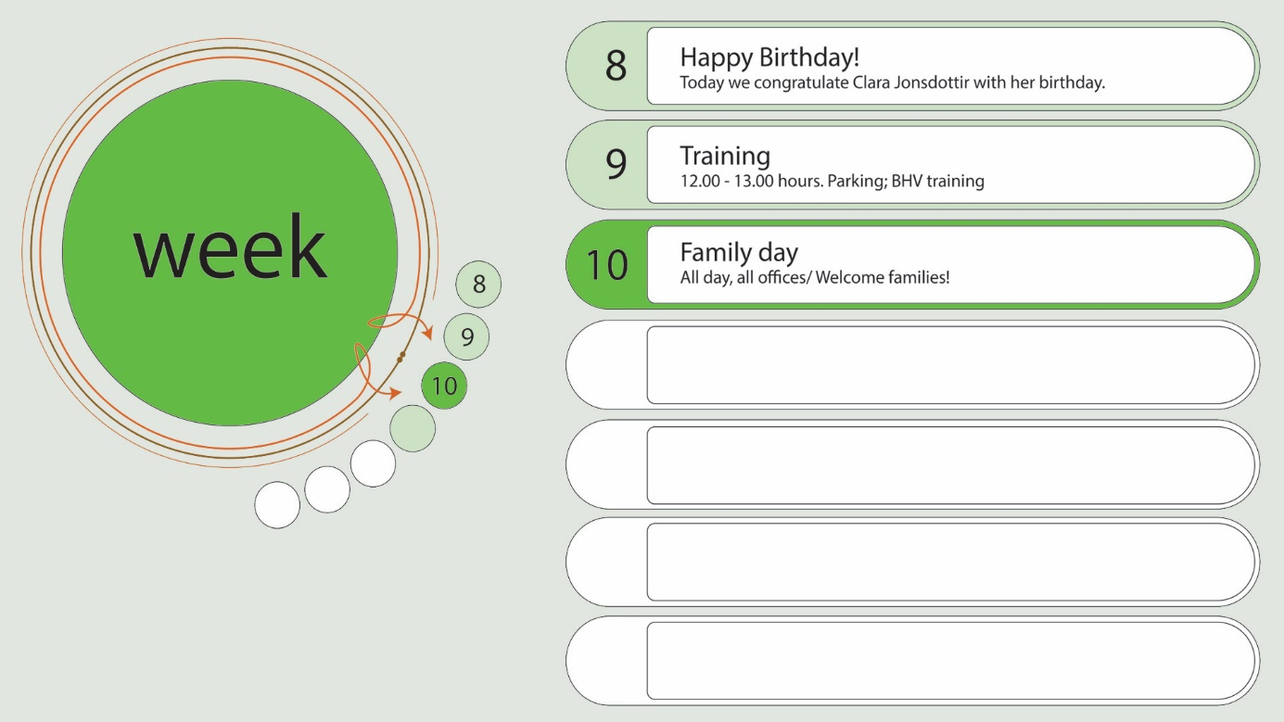

**Slide three:**

Zoom in to the current day. In the cms a photo can be selected for the content of the ball in the top left corner. The box has the same color as the highlighted ball of slide one and two. The current date and month is displayed below the picture. Supersize for the day number and smaller size for the month.

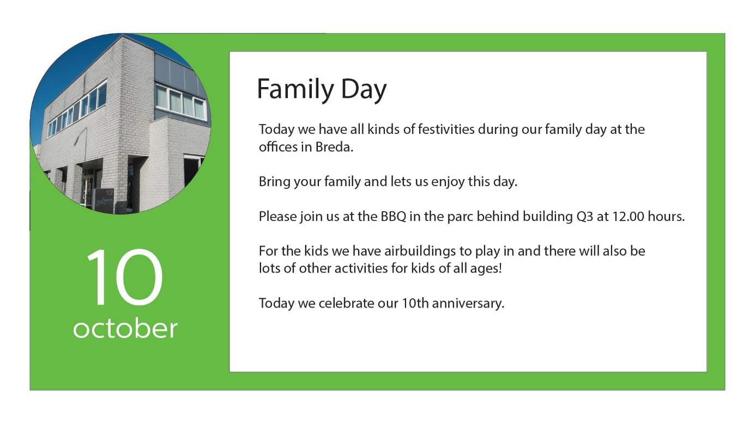In the text box there is a Header in large font and scalable text below the header.